**Perform Rolling Update Using a Replication Controller**

**Step 1: create a nginx yaml file**

#  vim nginx.yaml

apiVersion: v1

kind: ReplicationController

metadata:

name: my-nginx

spec:

replicas: 5

template:

metadata:

labels:

app: nginx

spec:

containers:

- name: nginx

image: nginx:1.7.9

ports:

- containerPort: 80



**Step 2: Create a ReplicationController using this yaml file.**

# kubectl create -f ./nginx.yaml



**Step 3: Set rolling update to the Replcation Controller**

# kubectl rolling-update my-nginx --image=nginx:1.9.1

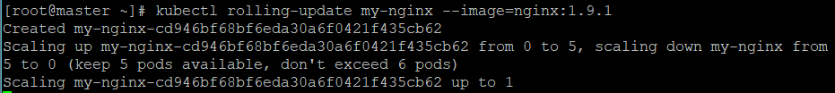

kubectl rollout history rc my-nginx



kubectl rollout undo rc my-nginx



**Step 4:** kubectl**added a** deployment **label to the pods, whose value is a hash of the configuration, to distinguish the new pods from the old**

# kubectl get pods -l app=nginx -L deployment

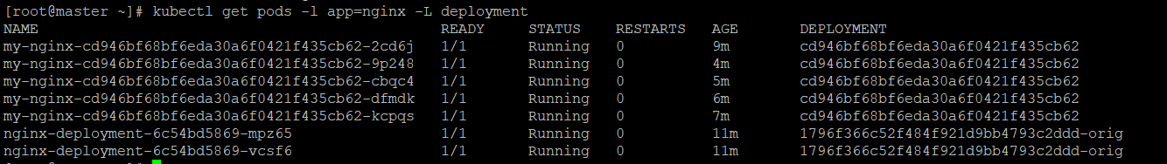

**Step 5: If you encounter a problem, you can stop the rolling update midway and revert to the previous version using --rollback**

# kubectl rolling-update my-nginx --rollback